

Project Title: ATM Simulation System

Submitted by -: Angel Saini
UID-: 25BCA10066
Class/Section-: 25BCA2-A
Institution Name-: Chandigarh University
Course-: Bachelor's of Computer Application( BCA)
Year-:2025
Instructor-: Ms. Anika Garg

Abstract
The ATM Simulation System is a mini project developed in the C programming language to simulate basic ATM functionalities such as checking balance, depositing, and withdrawing money. The project demonstrates the use of functions, loops, and conditional statements to create an interactive program. It provides a user-friendly interface for performing simple banking operations, including PIN authentication for security. This system helps beginners understand real-world applications of C programming concepts.

INTRODUCTION
Automated Teller Machines (ATMs) are essential components of modern banking systems. They enable users to perform financial transactions conveniently without human assistance. This project, ATM Simulation System in C, replicates the fundamental operations of an ATM.
The system interacts with the user via a simple menu-driven interface, allowing them to perform tasks like balance inquiry, withdrawal, and deposit securely. The primary goal of the project is to demonstrate how basic banking operations can be implemented logically using the C programming language, focusing on program structure, control flow, and data manipulation.

Objective
The main objective of this project is to create a console-based ATM simulation program that allows a user to:
- Authenticate with a PIN
- Check their account balance
- Deposit money
- Withdraw money
It aims to demonstrate the practical use of control structures, user-defined functions, and loops in C programming.

SYSTEM DESIGN AND APPROACH
1. System Architecture:
The system is designed as a modular, menu-driven program. Each operation—login, balance inquiry, deposit, withdrawal—is handled by a separate function to improve readability and reusability.
2. Flow of Execution:
- Program starts and prompts user for a valid PIN.
- After successful authentication, a main menu appears.
- User selects an operation (Check Balance, Deposit, Withdraw, Exit).
- Appropriate function executes and displays the result.
- The menu repeats until the user chooses to exit.
3. Tools and Technologies:
- Language: C
- Compiler: GCC / VS code
- Platform: macOS
4. Concepts Used:
- Functions – To modularize code and perform specific tasks.
- Conditional Statements – For decision-making (e.g., validating PIN).
- Loops – For menu repetition and input handling.
- Variables and Operators – For performing arithmetic operations.

Process / Implementation
- The program starts with a PIN verification system.
- Once authenticated, a menu is displayed with options to check balance, deposit, withdraw, or exit.
- The program uses loops and conditions to continuously interact with the user until they choose to exit.
- Functions are used for modularity — each operation (check balance, deposit, withdraw) is handled separately.
- The balance updates dynamically as transactions occur.

FLOWCHART
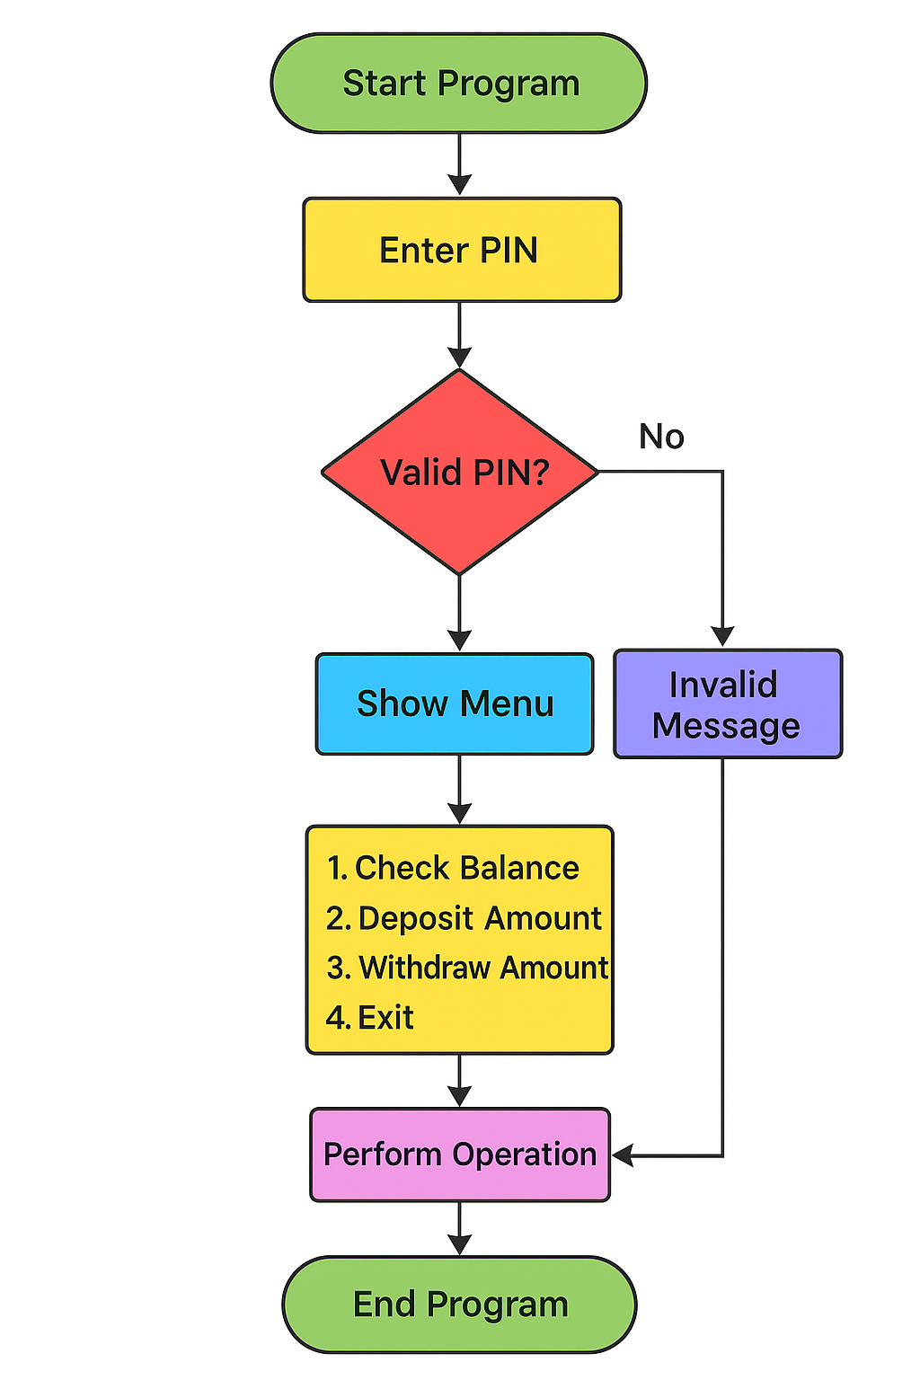

OUTPUT
Check Balance
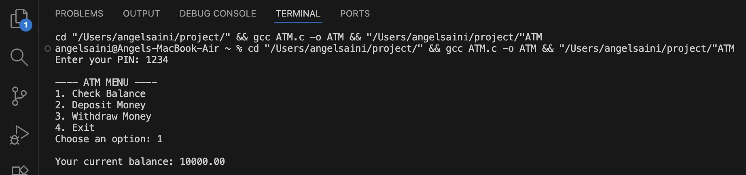
Deposit Money
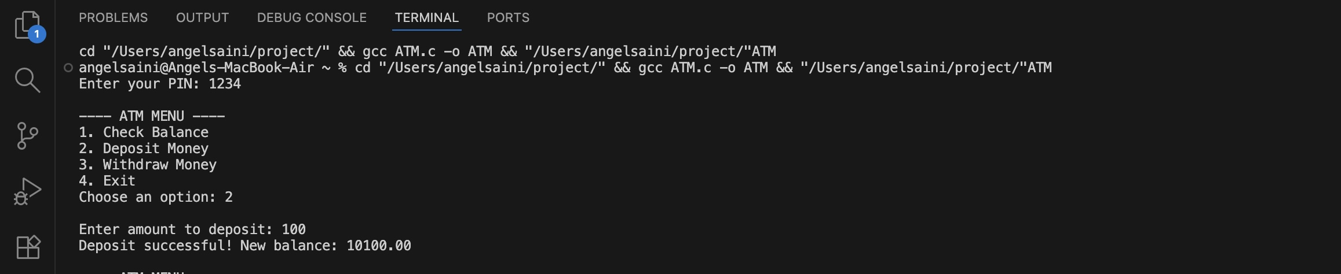
Withdraw Money
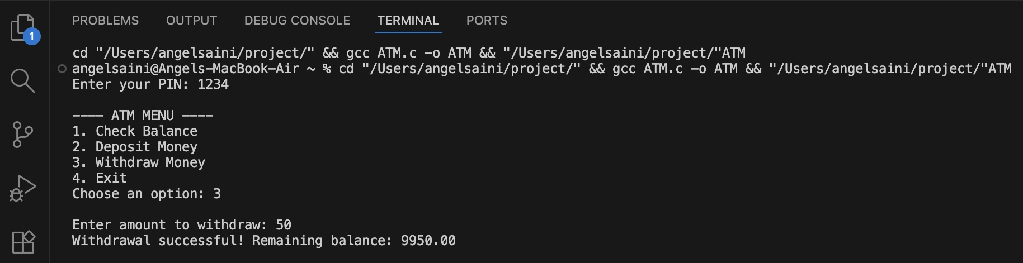

Exit
